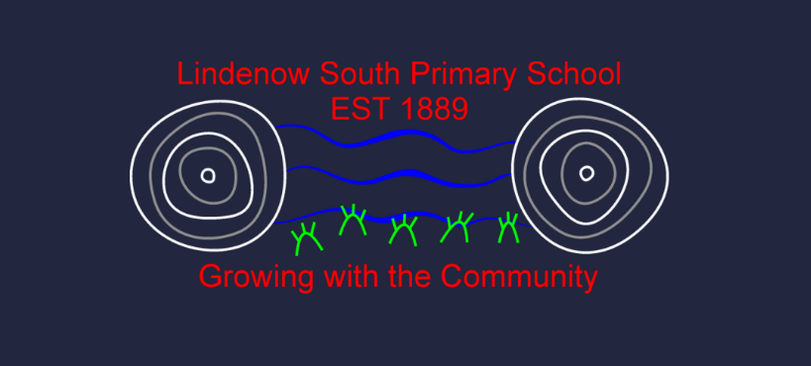 | Lindenow South Primary School
Curriculum Framework

Purpose
The purpose of this framework is to outline Lindenow South Primary School’s organisation, implementation and review of curriculum and teaching practices and to ensure that, taken as a whole, all eight learning areas are substantially addressed, unless an exemption applies.
The framework shows, at a high level, how the school will deliver its curriculum, how the curriculum and teaching practice will be reviewed, how we assess student learning, how we record and monitor of student performance, and when and how we report to parents.
This curriculum framework should be read alongside our whole school, curriculum area, year level and unit / lesson curriculum plans.

overview
Lindenow South Primary School provides all students with a planned and structured curriculum to equip them with the knowledge, skills and attributes needed to complete their schooling and to make a successful transition from school to work, training or further education.
Lindenow South Primary School is committed to offering a comprehensive curriculum based on the Victorian Curriculum F-10. The key points in this framework, and in line with the F–10 Revised Curriculum Planning and Reporting Guidelines, are a commitment to:
- A defined curriculum content is the basis for student learning
- Curriculum planning that is based on two-year bands of schooling rather than each year level
- Developing and publishing a separate whole-school curriculum plan that documents our teaching and learning program
- Reporting student learning against the achievement standards in the curriculum
- Reporting student learning to students and parents in line with the Department’s Reporting Student Achievement and Progress Foundation to 10 policy.
- Complying with Departmental policies relating to curriculum provision, including:
  - Physical and Sport Education — Delivery Outcomes
  - Languages Education
  - Holocaust Education – Delivery Requirements
Lindenow South Primary School aims to empower students to acquire, demonstrate, articulate, and value knowledge and skills that will support them, as life-long learners, to participate in and contribute to the global world and, practise the core values of the school: Think, Grow, Connect, and Inspire.

Implementation
Lindenow South Primary School implements is curriculum
- All students undertake year-long programs in English, Mathematics and Physical Education
- All students undertake science across all year levels
- All students undertake all Humanities disciplines (history, geography, citizens and citizenship, economics, and business), with history as a core semester learning program and elective options across the humanities.
- All students undertake at least one Arts discipline.
- All students undertake all technology disciplines (design and technologies, digital technologies)
- 2 – 6 students undertake a language (Indonesian)
- Humanities, technologies and Science key learning areas are completed in inquiry sessions.
At Lindenow South Primary School, class time is structured into a weekly timetable, with 5 hours of learning per day, broken into 60 minute sessions.
Further information on how our school implements the curriculum, including the learning areas provided at each year level/band of schooling, and the capabilities that are developed by students across these learning areas and the approximate time allocations for each learning area, is provided in our whole school, curriculum area, year level and unit / lesson curriculum plans.

Language provision
Lindenow South Primary School will deliver Indonesian as a Language, based on a connection with the Victorian Languages School.

Pedagogy
The pedagogical approach at Lindenow South Primary School Lindenow South Primary School is dedicated to providing a nurturing and dynamic learning environment where every child is valued and supported to achieve their best. This Pedagogical Approach Statement reflects our commitment to implementing the Framework for Improving Student Outcomes (FISO 2.0) to enhance educational practices and foster student success in our unique rural context.
Excellence in Teaching and Learning
We are committed to delivering high-quality education through:
- Targeted professional development that addresses rural-specific educational challenges and opportunities.
- Small group and individualized instruction to cater to the diverse learning needs of our students.
- Integration of local cultural and agricultural knowledge into the curriculum to make learning relevant and engaging.
Professional Leadership
Our leadership initiatives include:
- Developing leadership skills in all staff, encouraging them to take on roles such as leading small projects or initiatives.
- Providing support and resources for teachers to implement innovative teaching practices confidently.
- Regular community meetings to ensure the school’s vision aligns with community needs and values.
Positive Climate for Learning
To enhance our school’s learning environment, we will:
- Implement a buddy system pairing older and younger students to foster a sense of community and mutual respect.
- Develop resilience and wellbeing programs that address the specific needs of rural students.
- Ensure a safe and supportive environment by upholding clear, consistent behavioral expectations.
Community Engagement in Learning
Our approach to community involvement includes:
- Strengthening partnerships with local farms and businesses to provide students with practical learning experiences.
- Engaging parents and community members through workshops and school events that showcase student learning.
- Utilizing digital platforms to keep remote families engaged and informed about school activities and their children’s progress.

Assessment
Lindenow South Primary School assesses student progress in line with the Department’s Assessment of Student Achievement and Progress Foundation to 10 policy.
Students at Lindenow South Primary School will have multiple and varied opportunities to demonstrate learning and achievement. Teachers use assessment tasks that cover multiple curriculum levels to ensure that evidence of learning and growth is captured for every student.
- Teachers at Lindenow South Primary School use a combination of formative assessment for learning (to focus feedback and guide future learning) and summative assessment of learning (to determine what the student has learned at the end of a sequence of learning), alongside student self-assessment and reflection.
- Assessment is used in an ongoing way, to guide future lessons and learning, as well as to keep students and parents informed of student progress.
- Teachers will use a variety of assessment strategies to gather evidence about student achievement. The agreed assessment processes and tasks are documented in the Subject Unit Designs and Learning Sequences. The assessments may include, but are not limited to, tests and assignments, projects, portfolios, performances, discussions or student-teacher conferences.
- Assessment tasks are developed to support students to show their knowledge, skills and understandings and will include clear instructions, relevant supporting documents (scaffolds, planning documents, etc) and allow sufficient time for completion. Teachers will make modifications to the task to cater for students with additional learning needs.
- Lindenow South Primary School will develop Individual Education Plans (IEPs) for students who are part of the Program for Students with a Disability (PSD), Koorie students and students in ‘Out of Home’ care, in consultation with students, parents and where appropriate, with outside agencies.
- Teachers will assess the achievements of students with disabilities and impairments in the context of the Victorian Curriculum and the ‘Towards Foundation Level Victorian Curriculum’ where applicable.
- The English language proficiency of English as Additional Language EAL students will be assessed using the Victorian Curriculum F-10 EAL.
- Where possible, staff will participate in cross marking of assessment tasks (moderation) involving assessment rubrics and work samples so that staff can apply consistent judgements of student progress against Victorian Curriculum Standards across the school.

Reporting
Lindenow South Primary School reports student progress to parents in line with the Department’s Reporting Student Achievement and Progress Foundation to 10 policy. In addition, Lindenow South Primary School ensures that there is continuous sharing of assessment information formally and informally with parents/carers throughout the term/semester, including through twice-annual formal reporting.
At Lindenow South Primary School progress reports are issued to parents in both terms 2 and 4. Parent/Teacher interviews are conducted in terms 1 and 3 where parents are invited to discuss their child’s progress by making an appointment with their teacher.
The progress report will be in a written format easy for parents/carers to understand and will be accessible in digital form with the option to translate text from English to another language, to cater to our school community.
- Lindenow South Primary School will report directly against the Victorian Curriculum F-10 achievement standards.
- Both student achievement and progress will be included in the report.
- An age-related five-point scale, where the quality of a student’s achievement against what is ‘expected’ for students of that year level at the time of reporting, will be used for reporting against the achievement standards in English, Mathematics and Science (where applicable).
- Lindenow South Primary School will use either a learning goals scale or a learning dimensions scale for other areas of the curriculum.
- Opportunities will be provided for parents/carers and students to discuss the school report with teachers and/or school leaders.
Parent-teacher interviews, conducted twice-yearly, enable the opportunity to discuss the students’ progress and how they can continue to be supported at home. Interpreting services will be made available where required.

Curriculum and teaching practice review
School curriculum and teaching practice is reviewed against the Framework for Improving of Student Outcomes (FISO 2.0). FISO and the FISO improvement cycle help identify focus areas for improvement and to evaluate the impact of introduced initiatives.

Review of teaching practice
- Professional Learning Communities, which link the learning needs of students with the professional learning and practice of teachers and provide an opportunity for teachers to collaboratively evaluate the effect of high impact teaching strategies; and
- the Performance Development cycle, which provides an opportunity to provide feedback to teaching staff on their performance to support ongoing learning and development, with a focus on how student learning can be improved through improving teaching practice.

COMMUNICATION
This policy will be communicated to our staff in the following ways:
- Provided to staff at induction and included in staff handbook/manual.
- Discussed at staff meetings/briefings as required.

FURTHER INFORMATION and resources
This policy should be read in conjunction with the following policies on the Department’s Policy and Advisory Library (PAL):
- Curriculum Programs Foundation to 10
- Framework for Improving Student Outcomes (FISO 2.0)
- Assessment of Student Achievement and Progress Foundation to 10
- Digital Learning in Schools
- Students with Disability
- Koorie Education
- Languages Education
- Physical and Sport Education — Delivery Requirements
- Holocaust Education
- Reporting Student Achievement and Progress Foundation to 10
- Sexuality and Consent Education
- School Hours (including variation to hours)

Policy REVIEW and Approval
Policy last reviewed | 05/05/2024
Approved by | Principal – Bronwyn Joyce
Next scheduled review date | 05/05/2028

